**Theoretical foundation:**

Second car measures distance from the first car by Ultrasonic sensor of EV3. Depending on the distance the car decides whether to move or not, increase or decrease speed. There are three bounds of distance on which the speed is balanced. These are transition distance, constant distance, and critical value. Transition distance is used for speed up or down. If the second car stays in the transition distance area, it follows a certain speed. Constant distance is used to keep a certain distance from the first car. The car keeps it moving in a balanced speed while staying in constant distance area. Critical value is used to stop the car when the first car also stops. A very small distance is used to stop the whole program for safety reason so that it does not clash with any object.

Some topics to describe:-

* Lego Mindstorm EV3
* Ultrasonic sensor
* leJOS
* Some pictures of EV3 and Ultrasonic sensor
* Input and output port(which port we are using)
* Diagram of car position and corresponding speed
* Algorithm
* Sequence diagram
* Tools(Hardware/Software)

Lego Mindstorm EV3:

The EV3 brick serves as the control center and power station for our autonomous vehicle.

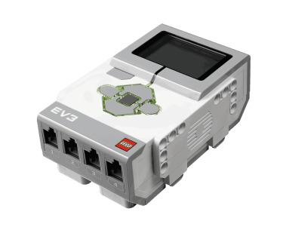

Figure: EV3 Brick

Reference:

<https://www.lego.com/en-us/mindstorms/products/mindstorms-ev3-31313>

It has several input and output ports. We are using output port D and input port A. One Motor is used with output port D . Ultrasonic sensor is plugged in input port A to measure distance from first car.

[Picture]

leJOS:

leJOS is a firmware replacement for Lego Mindstorms programmable bricks. It includes a JVM (Java Virtual Machine) and we can program with Java programming language.

Requirements:

* Blank SD card of at least 2GB and at most 32GB.
* EV3 hardware

Installation:

leJOS has been installed in EV3 hardware using windows installation method. The jdk1.7.0 version is used here.

Reference:

<https://sourceforge.net/p/lejos/wiki/Windows%20Installation/>

Algorithm:

Sequence diagram:

Need discussion

Use case diagram:

Drawn in paper

Fault in sensor reading:

1. Sometimes sensor starts reading infinite distance. We could not fix in which condition it starts reading infinite distance. On that case, the second car starts moving forward only.
2. If the color of first car is red, the ultrasonic sensor can’t detect the correct distance. In this case, the second car does not follow the first car according to algorithm.